Self Modifying Code
Presented by the Paid 4 WinRAR Group
FINAL REPORT
MARE spring 2020

Abstract
Self Modifying Code (SMC) as in an interesting subclass of binaries that modify their own binary code mid-execution. SMC code along with Overlapping Instructions (OI) are often used by malware to obfuscate their purpose and signature, evading antivirus detection and even more sophisticated reverse engineering tools such as IDA Pro. Using instrumentation debugging, CODISAM, which performs a combination of dynamic and static analysis to decompose and analyze SMC, a group of researchers in Canada [1]. In this class final, we propose and craft some SMC routines to demonstrate the effectiveness of SMC evasion and obfuscation ability, and evaluate some code with CODISASM.

Background
SMC code is a consequence that stems from the Von Neumann Architecture that permits instruction and user data to coexist within a single representation. The Turing Machine itself embodies this ideal, where a single stream of paper is allowed to be marked with 1s and 0s . There is a ticker that can read or write a single bit at a time. The tape strip can advance forwards or backwards.
Historically, the use of SMC code is more limited but it is used in OS for performance (optimizations) gains. Nowadays, SMC is used by malware authors in the form of packers: compression bits that thwart the static analysis of code. On top, several packers are highly advanced and include the ability to evade common virus detectors as well as impede reverse engineering.
The subject of SMC and Overlapping instructions continues to have an importance as malware authors find new ways to avoid detection and developers attempt to patch vulnerabilities and prevent the execution of malicious code. The Linux project has made several security policies such as SELinux and banning the execution of data memory pages. However, such methods can still be circumvented as evidenced by our exercise.

Purpose
In this semester-long project, our group intends to a) build an example of SMC on the Linux platform using the GCC toolchain to show its efficacy in bypassing traditional virus scanners. b) to run Codisasm on a various malware given in the Practical Malware Analysis textbook. c) To inquire on the feasibility of Codisasm as a practical anti-viral analysis tool. d) To perform codisasm on our own novelly constructed SMC and evaluate the effectiveness of our proposed techniques. and e) Evaluate the state of SMC in today’s security ecosystem.

The following report is organized in the following. First, we give a brief overview of CoDisasm, it’s capabilities and assess its analysis features. Second, we create a “Hello World” instance of a SMC to demonstrate just SMC. We then introduce the proper way to run arbitrary code in the context of SMC, we dub this the packer. We then propose several algorithms to pack and why they work. Finally, we analyze said methods and check for their efficacy with our CoDisasm method.

CoDisasm
The first thing we did was set up the CoDisasm. There were a number of initial hurdles we had to overcome. These issues were fixed after modifying the Makefile parameters. After compiling CoDisasm, we were able to test it with the original sample data used.

Here we create .asm file from a .exe one using the command:

./codisasmv2 -i ../tests/ccs2015/malardalen/statemate.exe
-l ../tests/ccs2015/malardalen/statemate.exe.asm

Output:
Total inst in trace: 0
Total static disas inst: 1375
Total decoded inst: 1375
Nb used addr : 6443
Total layers: 1
Layer 1 : 1375 instructions
(1375)
Unaligned:
6443 addresses used by 1 instructions
(6443)
Time: 0.207212

This program only had one layer. It was written in C and thus is rather straightforward and well constructed.
Here is a snippet of the statement.c file that we examined. It is based on a German firmware for car windows. I suppose it is meant to open and close windows but as none of us are fluent in German, we have no idea what anything does.
void generic_KINDERSICHERUNG_CTRL(void)
{
if (SYS_bit_get(Bitlist,active_KINDERSICHERUNG_CTRL_IDX))
{
switch (KINDERSICHERUNG_CTRL_KINDERSICHERUNG_CTRL_next_state)
{
case 1 : /** state ZENTRAL in chart KINDERSICHERUNG_CTRL **/
{
if (!(FH_TUERMODUL__SFHA_ZENTRAL || FH_TUERMODUL__SFHZ_ZENTRAL))
{
stable = 0;
FH_TUERMODUL__SFHZ_copy = 0;
FH_TUERMODUL__SFHA_copy = 0;

Here is an example of a .dot file which contains the dynamic analysis of this code

0x401789: mov byte ptr [0x4060a4], 0x0
0x401790: mov byte ptr [0x4060ed], 0x0
0x401797: mov byte ptr [0x4060f8], 0x3
0x40179E: jmp 0x7d\l
0x4017A0: jmp 0x7b\l
0x4017A2: movzx eax, byte ptr [0x406083]

SMC Hello World
In this example, we patch a test() function so that it always returns 0 (success).

#include <unistd.h>
#include <sys/mman.h>
int test() {
return 1 ? 1 : 0;
}
int main() {
mprotect((void*)((unsigned long)test - ((unsigned long)test % getpagesize())),
getpagesize(), PROT_READ | PROT_WRITE | PROT_EXEC);
*((char*)test + 5) = 0;
return test();
}
Patch.cpp

It is important to note here that we have to ask Linux to manually unprotect these memory pages of test() through the system call mprotect(). The most important flag here is the PROT_EXEC which allows us to execute pages. The test() function is hardcoded to always return 1. However we can patch this coed with some fancy address arithmetic. We use a magic offset of 5 which comes from our knowledge of assembly. The return value is exactly 5 bytes from the start of the function. GCC is smart enough to hard code the output to 1. A simple mov eax, 1 is the final assembly language. We simply change that to a 0. Running a test in bash results in a return value of 0!

.global _Z4testv
_Z4testv:
push rbp
mov rbp, rsp
mov eax, 1
pop rbp
ret
Patch.s (gcc -s patch.cpp -masm=intel)

In the assembly code, we have gcc label _Z4testv: as our global test() function. It has 2 instructions before which take up 4 bytes. The 5th byte is the mov function. The 6th byte is the argument 1. We patch this in runtime. .

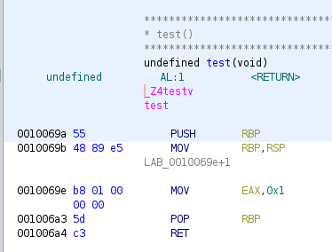

In many ways, SMC in assembly simulates Just in Time (JIT) compilers that can take advantage of runtime information to make certain decisions.

Packing Arbitrary Code (Dynamically loaded code)
It’s not normal to want to load arbitrary code in any program. Usually, if dynamic code is needed, it is left to the OS to execute and even then, it is usually well-defined. In shell.cpp. We have written a code that launches a shell, compiled that bytecode and loaded the assembly straight into a char array, which is then executed. We call the function mmap() which creates a new space in virtual memory. Again, note the PROT_EXEC flag which allows us to execute the code. A memcpy is invoked to move the global code[] to *mem, but the code[] need not be global and can be generated on the fly of course. Running the compiled snippet on a x86_64 linux machine will invoke the shell command.

#include <sys/mman.h>
#include <string.h>
char code[] = \
"\x48\x31\xc9\x48\xf7\xe1\x04\x3b\x48\xbb"
"\x2f\x62\x69\x6e\x2f\x2f\x73\x68\x52\x53"
"\x54\x5f\x52\x57\x54\x5e\x0f\x05";
int main() {
size_t sz = sizeof(code);
void *mem = mmap(nullptr, sz, PROT_READ | PROT_WRITE | PROT_EXEC, MAP_PRIVATE | MAP_ANON, -1, 0);
memcpy(mem, code, sz);
((void(*)())mem)();
}
Shell.cpp

We can disassemble the char code block in Ghidra.
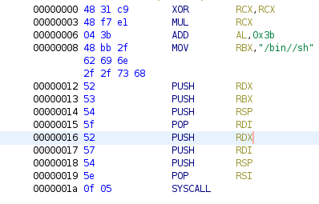
Decompiled char[] block

We note that a) there is a string called “/bin//sh” which is the location of the shell executable followed by some stack pushing and then a syscall, not a normal call! This means our executable will only work on *nix machines with syscall support.

Our Packer
Our implemented packer uses a combination of SMC and OI to achieve obfuscation. As observed by [1], most malware performs activity on the last “wave” of code. This usually means a simple two layer packer. However, we wanted to execute code on ALL layers. To do this, we have created a ONION style packer where each instruction is obfuscated. Additionally, we have implemented a very simple cipher stream algorithm which itself modifies the next instruction. To decode the next instruction, you need both, the current instruction and the following instructions “secret”.. In essence, our depacker acts like an onion peeler, peeling and executing one instruction at a time. In this way, we effectively create a new “wave” for every instruction executed, with the routine overwriting itself after each step. This results in all program side effects being spread throughout the unpacking routine, rather than finishing in a jump to a single region with the plain unpacked code.

Encoding
Decoding
Instr 1
Instr 2
Instr n
🔑 Key 1
🔑 Key n-1
🔑 Key 2
...
block 1
Instr 1
block 1
Cipher text
Instr 2
...
...
...
🔑 Key 1
🔑 Key 2
Instr n
block 1
🔑 Key n-1
A cipher using XOR functions. If the keys are random then you have a one pad. If the keys are recursively generated from a seed secret then we have a stream cipher.

On principle, it exploits a fundamental oversight in many disassemblers, where they advance the instruction pointer in disassembly exactly by the length of each instruction, not accounting for jump targets. Because of this, if an instruction contains a relative jump to halfway in between the bytes of a following instruction, the start of each instruction as viewed by the disassembler will become offset from the start of the true instructions that are executed, resulting in the disassembler producing an incorrect output.

jmp 4
db 0x69 0x84
db [instruction, 8 bytes nop padded]
jmp 10
db [offset to next instruction]
push ecx
mov ecx, [eip-16]
add ecx, [eip-35]
mov [eip+5], ecx
pop ecx

Our algorithm works by padding each instruction to 8 bytes, then generating a list of offsets, such that adding an 8 byte offset to the previous 8 byte padded instruction with overflowing will yield the next 8 bytes to be executed. After each instruction, the offset is read and added to the previous instruction, yielding the next instruction which is then overwritten right after the instruction pointer such that it executes next, repeating the process. In order to further confuse disassemblers, we embed these bytes inside the displacement parameters of an imul instruction and use relative jumps to execute the correct bytes. This doesn’t fundamentally change the functionality of our algorithm.

Simple Example
Here, we do a breakdown of a basic example illustrating how our packer works using a real target which we have written in C. The target has a secret() which can contain arbitrary executable C code. In this example, we have chosen to print the string “Secret!” one character at a time.

#include <stdio.h>
int data[0x10000] = {1};
void secret() {
putchar('S');
putchar('e');
putchar('c');
putchar('r');
putchar('e');
putchar('t');
putchar('!');
putchar('\n');
}
int main() {
secret();
return 0;
}
Target.c

We need to allocate a large buffer in the stack which is why on line 2, there is a huge data block. This will be where our “self modified code” will finally reside. In other words, our packer will patch secret() into this data block!! Instead of jumping to the normal secret() function, we will eliminate it and jump to the data[] block and execute and unroll our SMC there. This technique where we patch a function to jump elsewhere is known as trampolining.

Our packer has the following usage (uses Cargo to build and run):
./cargo run [target] [function name] [output]

First, packer run converts the code to assembly. Here is a trimmed output from the packer itself:

Packing subroutine "secret" <target+00001139>
00001139 <+0000> 55 push rbp
0000113a <+0001> 48 89 e5 mov rbp,rsp
0000113d <+0004> bf 53 00 00 00 mov edi,’S’
00001142 <+0009> e8 e9 fe ff ff call 0000000000001030h
00001147 <000e+> bf 65 00 00 00 mov edi,’e’
0000114c <+0013> e8 df fe ff ff call 0000000000001030h
00001151 <+0018> bf 63 00 00 00 mov edi,’c’
00001156 <+001d> e8 d5 fe ff ff call 0000000000001030h

Note these calls actually point to putchar(). The character has been encoded in ASCII.

Creating code cave at 00004120 <.data+100>
Patching offsets
0: 90909000000053BF -> 909090FFFFBED8E8 (+000000FFFFBE8529)
1: 909090FFFFBED8E8 -> 90909000000065BF (+FFFFFF0000418CD7)
2: 90909000000065BF -> 909090FFFFBE7AE8 (+000000FFFFBE1529)
3: 909090FFFFBE7AE8 -> 90909000000063BF (+FFFFFF000041E8D7)

We generate offsets in parenthesis, these are the key. The right of the arrow represents our “coded” ciphertext. Our offsets skip the first two assembly instructions and start from 0x113d. Remember that the bytes are written in little endian format. The first coded instruction is “BF 53” which is reversed in line 0.

Then the packer generates a lot of assembly and copies it into the char array stack variable in the target. Here is just the “first block” that unpacks the secret instruction 0xbf53 highlighted in CYAN. Next, we have some padded NOPS (0x90) in ORANGE. The next jump routine 0xeb 0x0a will jump 10 forwards. The secret key and offset to retrieve the next instruction is highlighted in GREEN and is 8 bytes long. We use $rcx to store the new instructions value and paste it back to the YELLOW text which is cleverly the beginning of the next instruction. Note that the disassembled instructions at 0x4122 to 0x04136 are incorrectly identified.

Packed assembly:
00004120 <+0000> eb 02 jmp short 4124h
00004122 <+0002> 69 84 bf 53 00 00 00 90 90 90 eb imul eax,
[rdi+rdi*4+53h],
0EB909090h
0000412d <+000d> 0a 69 84 or ch,[rcx-7Ch]
00004130 <+0010> 29 85 be ff ff 00 sub [rbp+0FFFFBEh],
eax
00004136 <+0016> 00 00 add [rax],al
00004138 <+0018> 51 push rcx
00004139 <+0019> 48 8b 0d f0 ff ff ff mov rcx,[4130h]
00004140 <+0020> 48 03 0d dd ff ff ff add rcx,[4124h]
00004147 <+0027> 48 89 0d 05 00 00 00 mov [4153h],rcx
0000414e <+002e> 59 pop rcx
0000414f <+002f> eb 02 jmp short 4153h
00004151 <+0031> 69 84 e8 d8 be ff ff 90 90 90 eb imul eax,
[rax+rbp*8-4128h],
0EB909090h
We have thus completed the cycle and the unpacker will work magic itself.

Here’s what actually gets executed, with the RED bytes being skipped over by relative jumps:
Packed assembly *ACTUAL* execution:
00004120 <+0000> eb 02 69 84 jmp short +4h
00004124 <+0004> bf 53 00 00 00 mov edi, 53h
00004129 <+0009> 90 nop
0000412a <+000a> 90 nop
0000412b <+000b> 90 nop
0000412c <+000c> eb 0a 69 84 29 85 be ff ff 00 00 00 jmp short +10h
00004138 <+0018> 51 push rcx
00004139 <+0019> 48 8b 0d f0 ff ff ff mov rcx,[4130h]
00004140 <+0020> 48 03 0d dd ff ff ff add rcx,[4124h]
00004147 <+0027> 48 89 0d 05 00 00 00 mov [4153h],rcx
0000414e <+002e> 59 pop rcx
0000414f <+002f> eb 02 69 84 jmp short 4153h
00004151 <+0031> e8 d8 be ff ff callq <putchar>
00004156 <+0036> 90 nop
00004157 <+0037> 90 nop
00004158 <+0038> 90 nop

Disassembling our Packer
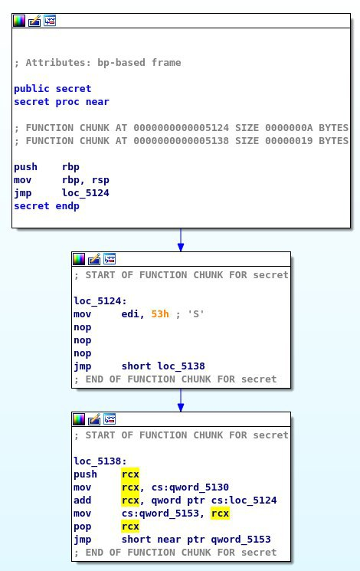
Being confused and unable to understand our SMC, packed. . Only the first layer it can read a bit but then it sees confusion!

Ultimately, no disassembler, decompiler, or unpacking script that we tested was able to correctly handle the combination of overlapping instructions and self modifying code. Analyzing a routine packed with our tool is much more difficult, even at runtime with a debugger. In our testing, we found that GDB won’t even show the true instructions being executed without manual intervention due to the changing instruction boundaries.

Porting to 32 bits
So unfortunately, Codisasm uses an emulator that runs on 32 bit executables only so we attempted to port our code to 32 bits. There are a few interesting problems here available on the 32bit branch of our code.

Register Size
x86 instructions can be up to 15 bytes, but a register can now only hold 4 bytes instead of 8. Our offset scheme still requires 8 byte addition though. The trick is to combine two registers and use them as one! The final instructions is simply: add then adc. The carry is needed to be considered from the first lower nibble add. Unfortunately, more stack movement is needed, increasing overhead even more!

Offset Calculation
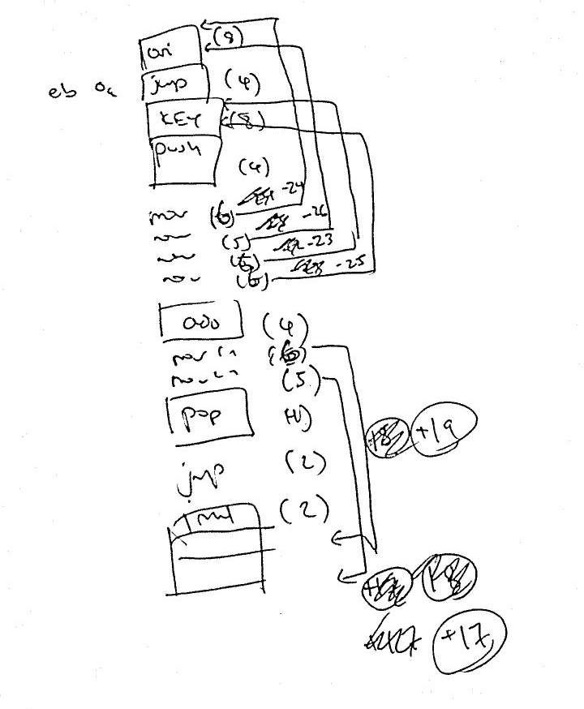
So as it turns out, we are no longer able to use the old offsets (which are by the nature of this project must be baked into the assembly). So we need to recalculate the offsets based and add code in the middle.

If anyone remembers why GOTO statements were terrible in languages like BASIC and Fortran it is because it makes adding code in between lines tedious. That is, you need to shift your offsets everytime instruction lengths change. In other words, some incremental repetition must be used by hand to solve such a problem.

To the right, I have shown some work by hand. Below is the final assembly.

# Let's
# Add two 64 bits ints together
# ecx:ebx to edx:eax
# Works for both signed and unsigned bits
.intel_syntax noprefix
mov edx, (eip-24) # a_l -- grab upper nib
mov eax, (eip-26) # a_h -- grab lower nib
mov ecx, (eip-23) # b_l -- grab upper nib
mov ebx, (eip-25) # b_h -- grab lower nib
add eax, ebx # a_l + b_l -- add lower nibs
adc edx, ecx # a_h + b_h -- add upper nib (takes carry from lower
mov edx, (eip+19) # move...
mov eax, (eip+17)

Linux and Memory Protection
Actually SMC is not considered good practice in normal high level coding. It is considered dangerous and difficult to maintain. Linux has safeguards against SMC. In order to get SMC in linux, several methods were deployed which were mentioned before. Some include mmap() or mprotecting() memory pages. Others include allowing gcc to exec on the stack. Other kernel runtime based protections exist. While the packer works on x86_64, we could not get it working on x86 even after we patched it due Linux. Further work is required.

Future Work
While our “multi wave” packer was successful in our original goal, our packing technique for each instruction is fairly static, and it would be relatively easy to write a specialized script to reverse the “peeling” process and unpack a binary packed with our tool. Future iterations of our tool could include a more robust stream cipher, or introduce some form of randomization. Additionally, our cipher adds quite a lot of overhead, perhaps we could generate more efficient jumping techniques to reuse assembly to minimize this overhead.

Another problem that we faced was in solving the dependencies of packed instructions. When a function contains relative jumps inside of itself, our unpacker fails due to the linear nature of instruction unpacking. A possible future improvement might be to construct an execution graph after disassembly, only unpacking instructions as needed.

References
CCS '15: Proceedings of the 22nd ACM SIGSAC Conference on Computer and Communications Security October 2015, Pages 745–756
Sikorski, Michael, and Andrew Honig. Practical malware analysis: the hands-on guide to dissecting malicious software. no starch press, 2012.
Mavrogiannopoulos, et. al https://www.esat.kuleuven.be/cosic/publications/article-1529.pdf . Useful for crafting and classifying SMC types. 2012.
https://github.com/8l/codisasm. Source code available for the paper.
https://github.com/Foltik/MARE

Authors


Jack Foltz
Jack has a website with his name in the domain. He has a dog that is good at writing Rust code among other types of code. Jack enjoys hacking on Linux, Windows and Mac, and creating slow native apps with javascript. He reverse engineers COBOL mainframes for big banks in his free time.



Andrew Park
Andrew has a loud server rack at home. He also carries a laptop with a loud fan. It is a gaming laptop so that is not only acceptable but desirable. Andrew enjoys electrical engineering with a special interest in designing passive filters for audiophile speakers.



Brian Qiu
Brian enjoys snacking on grapes and writing LaTeX on Facebook. He spends his time goofing off on social media, playing video games and drinking off his sorrows. There is a picture of Richard Stallam in his basement.

I asked my norwegian friend who speaks german and apparently it has something to do with child locks
Apparently, this approach was often used on some 16 bit architecture such as the Z80.

